COSC 4377 – Networking - Kevin B Long

# interlocking-uh-m-186.eps

Homework #2

Due 11:59am, Sunday, 10 February 2019

Multiple submissions accepted.

Name:___James Richardson____________________ Peoplesoft ID:_____1555520______

1. (10 pts) Socket Programming

I am going to fit in a few Socket Labs in our homeworks this semester, which are based on the programming language Python. They’re all in the Socket assignments folder in our class drive, but we’re not assigning them yet (we’re trying to get everyone added to the Microsoft Imagine program). But you can prepare if you want to try and get ahead a little – consult the document “Getting Started with Python”

One choice for a Python Interpreter is PyCharm. If you go that route, you’ll find it runs on Mac, Windows and Linux. Start by going to the installation page for all platforms: <https://www.python.org/downloads/> and choose a current release as your base. Then you’re ready to install PyCharm on top. For that, go here: <https://www.jetbrains.com/pycharm/download/>.

If you wish to install Windows on your Mac and run Python in it (and why not have Windows available on your Mac, it’s free), you’ll need two things: a virtual machine program that will host the Windows OS, and then Windows. For the former, install VirtualBox ([https://www.virtualbox.org](https://www.virtualbox.org/)), free. Paid alternatives exist.

If you need the Windows software to install on top of the virtual machine (or for installing on a Windows machine), you can take advantage of UH's participation in [Microsoft's Imagine program](https://e5.onthehub.com/WebStore/ProductsByMajorVersionList.aspx?ws=259c59cc-ae09-e211-bd05-f04da23e67f6&amp;vsro=8).  Read more about that in "[Downloading Windows 10.pdf](https://drive.google.com/open?id=1ZivscEYrWognSE0IIZIsBKJlIhMQ39ql)" in the socket folder on our class drive.

Next week you’ll do the web server socket assignment in python. For now, just get it installed and include a snapshot showing it’s up you got the basic “Hey Michael” program to run (but maybe with your name).

<include snapshot here>

1. (10 pts) Complete the third Wireshark lab. The topic is SSL, Secure Sockets Layer, used to encrypt communications between web browsers and servers, for example. It was in force when the lab was originally written, but has since been “deprecated” or removed from use. You will almost certainly find that every site you try uses TLS instead. Therefore, for this lab it’s likely you’ll need to use the accompanying pcap file. Find the name of the one you need by reading the lab, and then look for it in the folder of pcap files inside the Wireshark Labs folder on our class drive.
2. (4 pts) Visit the Transmission Versus Propagation Delay applet at the companion Web site at <https://wps.pearsoned.com/ecs_kurose_compnetw_6/216/55463/14198702.cw/index.html>
   1. Among the rates, propagation delay, and packet sizes available, find a combination for which the sender finishes transmitting before the first bit of the packet reaches the receiver. **Take a snapshot** and paste it here.

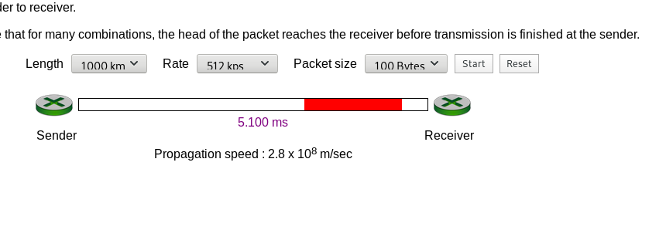

* 1. Find another combination for which the first bit of the packet reaches the receiver before the sender finishes transmitting. Take a snapshot and paste it here.

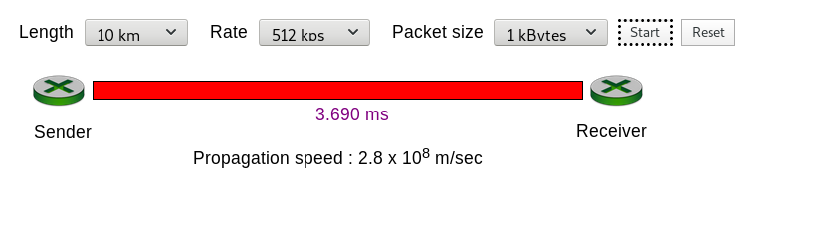

1. (4 pts) Let’s do some more delay calculations:
   1. Calculate how long it takes to transmit a 100-byte packet onto a 10Mbps network:

100 *8.0 / (10 * 1000 * 1000) * 10 ** 3 = .08 ms

bytes * (bits / byte) / (bits / s)

* 1. How long for a bit to propagate on a 100km network at 2.8x108 m/sec?

X=Vt => t = X/V = 100 * 1000 / (2.8*10**8) = 0.000357s = 0.357 ms

1. (4 pts) How long does it take a packet of length 3,000 bytes to enter and propagate over a link of distance 25,000 km, given a propagation speed 2.5⋅108 m/s, and transmission rate 2 Mbps?
   1. Total time = transmission time + propagation time

transmission time = size / transmission rate = 3000 * 8 / (2 * 1000 * 1000) = 0.012 s

propagation time = distance / speed = 25000 * 1000 / (2.5 * 10**8) = 0.1 s

Total = 0.012 s + 0.1s = 0.112s

More generally, how long does it take a packet of length *L* to propagate over a link of distance *d*, propagation speed *s*, and transmission rate *R* bps?

* 1. (I will assume that L is in BITS for convenience to me :) )

t = L / R + d / s

1. (6 pts) Suppose Host A wants to send a large file to Host B. The path from Host A to Host B has three links, of rates R1=800 kbps, R2=1.5 Mbps, and R3=1 Mbps

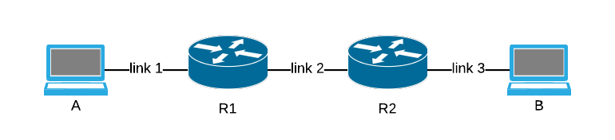

* 1. Assuming no other traffic in the network and ignoring any router delay, what link determines your throughput for the file transfer?

The slowest link, in this case the 800kbps link R1

* 1. Suppose the file is 6 million bytes. Given your answer above, about how long will it take to transmit the file to B?

6000000 / (800 * 1000) = 7.5s

* 1. Repeat (a) and (b), but now with R2 reduced to 600 kbps.

(a) throughput: 600 kbps (b) transmission time: 6000000 / (600 * 1000) = 10s

1. (4 pts) Visit the Queuing and Loss animation at the companion web site. A link can be found in the Extras folder (look for Link to Interactive animations) or in a problem above.
   1. With the maximum emission rate and the minimum transmission rates, calculate the traffic intensity?

Max emission: 500 packets/s; Min transmission: 350 packets/s;

Traffic Intensity: La/R = 500 / 350 = 1.428

Run the applet with these rates and determine how long it takes for packet loss to occur. Then repeat the experiment a second time and determine again how long it takes for packet loss to occur.

* 1. Are the values different? Why or why not?

Yes they are different, the times when packets are generated is random. Theoretically we would get a case where no packets are dropped if the time between packet generation is small enough.

1. (2 pts) (P2) Equation 1.1 gives a formula for the end-to-end delay of sending one packet of length L over N links of transmission rate R.

$d_{end−−end}=N\frac{L}{R}$

Generalize this formula for sending P such packets back-to-back over the N links.

________________________________________________________________________

1. (4 pts) (P5) Review the car-caravan analogy in section 1.4. Suppose the caravan travels 300 km at a speed of 100km/hr, and that we begin counting just as the group decides which path (and thus which booth) they’ll, and the first car pulls up to the booth to begin payment. They begin at tollbooth #1, pass through tollbooth #2 further down the road, and finish after 30 seconds of more driving after tollbooth #3. Assume there are ten cars total, that the tollbooths are evenly spaced and that it takes 15 seconds per car to process at a booth.
   1. How long will it take a car to travel (propagate) from one booth to the next?

½ of 300km / 100km/hr = ½ of 3 hours, so 90 minutes minutes

* 1. What is the end-to-end delay from the time the first car pulls up to the tollbooth #1 to the time the last car arrives at tollbooth #3? Show the formula you used.

Total = Transmission time + propagation time + transmission time + propagation time

= 2 * transmission time + 2 * propagation time

= 2 * 10 * 15 seconds + 2 * 90 minutes

= 185 Minutes

1. (7 pts) P6. This elementary problem begins to explore propagation delay and transmission delay, two central concepts in data networking. Consider two hosts, A and B, connected by a single link of rate R bps. Suppose that the two hosts are separated by m meters, and suppose the propagation speed along the link is s meters/sec. Host A is to send a packet of size L bits to Host B.

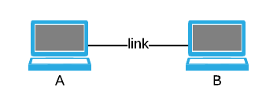

1. Express the propagation delay, *d*prop, in terms of *m* and *s*.

_________________

1. Determine the transmission time of the packet, *d*trans, in terms of *L* and *R*.

_________________

1. Ignoring processing and queuing delays, obtain an expression for the end-to-end delay.

_________________

1. Suppose Host A begins to transmit the packet at time t=0. At time t= *d*trans, where is the last bit of the packet?

____________________________________________________

1. Suppose *d*prop is greater than *d*trans. At time *t=dtrans*, has the first bit reached host B?

____________________________________________________

1. Suppose *d*prop is less than *d*trans. At time *t=dtrans*, where is the first bit of the packet?

____________________________________________________

1. Suppose s=2.5⋅108, L=6000 bits, and R=1250kbps. Find the distance *m* (but in kilometers if > 1000 m, please) so that *d*prop equals *d*trans.

____________________________________________________

1. (6 pts) P10. Consider a packet of length L that begins at end system A and travels over four links to a destination end system B. These four links are connected by three packet switches (routers). Let di, si, and Ri denote the length, propagation speed, and the transmission rate of link i, for i=1,2,3,4. The packet switch delays each packet by dproc.

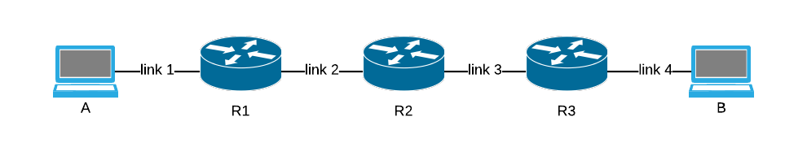

* 1. Assuming no queuing delays, in terms of *di*, *si*, *Ri*, (i=1,2,3,4), and *L,* what is the total end-to-end delay for the packet? Measure from the moment you begin transmitting the first bit of the first packet at A until the first bit of the last packet arrives at the last system B. It might be easier to group the d’s together and then the s’s and so on when you write out the answer. Order doesn’t matter. Just remember that d, s, and R are different for each link and router.
  2. Suppose now the packet is 1,500 bytes, the propagation speed on all 4 links is 2.5⋅108m/s, the transmission rates of all 4 links are 2 Mbps, the packet switch introduces a processing delay of 4 msec, the lengths of the links 1-4 are 2,000 km, 3,000 km, 4,000 km, and 5,000 km. For these values, what is the end-to-end delay?
  3. (4 pts) Now suppose *R1=R2=R3=R* and *dproc=0*. Further suppose the packet switch does not store-and-forward packets but instead immediately transmits each bit it receives before waiting for the entire packet to arrive. The processing to figure that out which would usually happen after enough of the packet has arrived to see the addresses inside of it is not required (this is how circuit-switched networks behave). So what is the end-to-end delay?

1. (2 pts) P12. A packet switch receives a packet and decides on the next link it should take. It puts the packet into the queue, but there is still half of a packet remaining in the buffer that is in the middle of being transmitted, and 2 others. You’re at the back of that line. Packets are transmitted in order of arrival, all packets are 1,536 bytes and the link rate is 2.048 Mbps.
   1. What is the queuing delay for the packet?

__________________

* 1. More generally, what is the queuing delay when all packets have length *L*, the transmission rate is *R*, *x* bits of the currently-being-transmitted packet have been transmitted, and *n* packets are already in the queue?

__________________

1. (2 pts) P13. Suppose N packets arrive simultaneously to a link at which no packets are currently being transmitted or queued. Each packet is of length L and the link has transmission rate R.
2. What is the average queuing delay for the *N* packets? You may find yourself with a series of numbers that you need to reduce in complexity. One place for doing that is <http://oeis.org/>.

________________________________

1. Now suppose that *N* such packets arrive to the link every *LN/R* seconds. What is the average queuing delay of a packet?

_____________________________

1. (4 pts) (P23) Consider the following figure based on 1.19a:

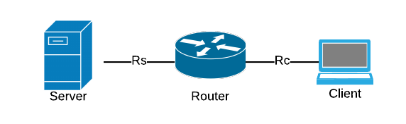

Assume that we know the bottleneck link along the path from the server to the client is the first link with rate *Rs* bits/sec. Suppose we send a pair of packets, the second immediately after the first, from the server to the client, and there is no other traffic on this path. Assume each packet of size *L* bits, and both links have the same propagation delay *d*prop.

1. Since Rs is the bottleneck (and Rc is not), what exactly is the difference between the two? In other words, which of the various variables we’ve explored so far must differ between the two and how?

__________________________________________________________________

1. What is the packet inter-arrival time at the destination? This is asking how long elapses between when the first packet completely arrives and the second packet completely arrives. That is, how much time elapses from when the last bit of the first packet A arrives until the last bit of the second packet B arrives?

____________________________

1. Now assume that the second link is the bottleneck link (i.e., Rc<Rs). Is it possible that the second packet queues at the input queue of the second link? Explain.

☐Yes ☐No Explain: ____________________________________________________________________________________________________________________________________________________________________________________________________________________________________________________________________________

1. Now suppose that the server sends the second packet *T* seconds after sending the first packet. How large must *T* be to ensure no queuing before the second link?

___________________________

1. (4 pts) P25. Suppose two hosts, A and B, are separated by 50,000 kilometers and are connected by a direct link of R=4.0 Mbps. Suppose the propagation speed over the link is 2.5⋅108 meters/sec.
2. How long does it take for a bit to cross the network (*dprop*)?

______________________

1. How many bits can you send in that amount of time? This is called the bandwidth-delay product, *R*⋅*dprop*.

______________________

1. As we’ve discussed in class, you transmit the bit by changing the shape of part of the carrier sine wave. Although we don’t know the frequency of the media yet, we can calculate how “wide” the part of the sine wave is that is encoding a bit, assuming we include any guard space on either side the encoding electronics might wish to include. So then, what is the width (in meters) of one bit in this link? I suggest taking the length of the link and dividing by the number of bits that would fill it, given the bandwidth and propagation speeds. The length we know, and the number of bits is just the answer above.

___________________

1. Derive a general expression for the width of a bit in terms of the propagation speed *s,* the transmission rate *R,* and the length of the link *m*. Use the same approach as above, just with variables.

________________

1. (13 pts) Traceroute

This problem will require a bit of experimentation.

Traceroute a route to a major university web site, such as [ww.rice.edwu](http://www.rice.edu/), [www.uh.edu](http://www.uh.edu/), [www.itesm.mx](http://www.itesm.mx/), [www.stanford.edu](http://www.stanford.edu/), etc. Make sure it starts with www. You may have to try different destinations and try from different places to find one that will give you a good traceroute. That means a traceroute that may have some rows of asterisks, but the last row must not.

For example, here’s one I did from Germany to rice.edu:

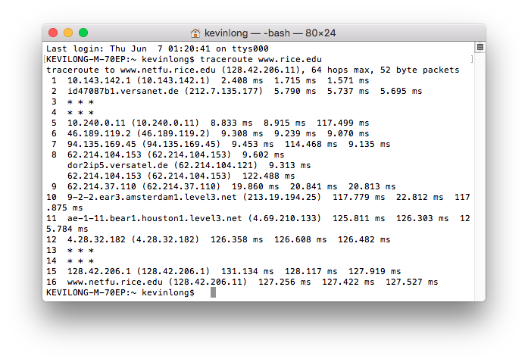

1. Paste your traceroute below:

**[yelsek@apollo ~]$ traceroute www.rice.edu**

**traceroute to www.rice.edu (52.0.127.56), 30 hops max, 60 byte packets**

**1 mission-control.reamerhouse.com.0.168.192.in-addr.arpa (192.168.0.1) 0.442 ms 0.561 ms 0.657 ms**

**2 96.120.17.17 (96.120.17.17) 9.982 ms 9.970 ms 9.930 ms**

**3 ae-104-rur02.royalton.tx.houston.comcast.net (68.85.250.169) 11.956 ms 11.916 ms 12.043 ms**

**4 ae-2-rur01.royalton.tx.houston.comcast.net (162.151.134.65) 11.816 ms 11.770 ms 11.815 ms**

**5 ae-29-ar01.bearcreek.tx.houston.comcast.net (68.85.245.85) 11.963 ms 12.389 ms 12.359 ms**

**6 be-33662-cr02.dallas.tx.ibone.comcast.net (68.86.92.61) 19.550 ms 21.178 ms 21.094 ms**

**7 be-12495-pe03.1950stemmons.tx.ibone.comcast.net (68.86.85.194) 19.207 ms 15.751 ms 15.614 ms**

**8 50.248.118.202 (50.248.118.202) 18.758 ms 13.373 ms 14.961 ms**

**9 54.239.105.121 (54.239.105.121) 43.582 ms 54.239.105.123 (54.239.105.123) 42.789 ms 54.239.105.117 (54.239.105.117) 49.276 ms**

**10 * * \***

**11 * * \***

**12 * * \***

**13 54.240.229.217 (54.240.229.217) 47.180 ms 54.239.104.151 (54.239.104.151) 45.188 ms 54.240.229.185 (54.240.229.185) 44.327 ms**

**14 * * \***

**15 * * \***

**16 * * \***

**17 * * \***

**18 * * \***

**19 * * \***

**20 * * \***

**21 * * \***

**22 * * \***

**23 * * \***

**24 * * \***

**25 * * \***

**26 * * \***

**27 * * \***

**28 * * \***

**29 * * \***

**30 * * \***

1. How many steps did your traceroute require? 30
2. What’s the exact name of the type of packet being used to reach the routers we want to respond in each step? Not the name of the Unix program (ping), but the name of the packet type at layer 3.

icmp (lol ping tells me its using icmp when I ping something so I cheated)

1. You might have an entry that resembles row 8 in my traceroute – one number with multiple addresses. What’s the significance of this?

It means they have multiple routers at that level because its a high traffic environment. They just have whatever router is available at that time pick up the slack and route the customer.

1. What do rows of just asterisks represent?

20 – Two thirds!!

1. Why do you think you can have asterisks and yet still reach your destination?

The routers are like “Nah bro I ain’t gonna tell you my name but I’ll tell you how to get to where you wanna go because I’m a nice dude just worried about my own privacy, you understand right?”

1. Some steps report times ***less*** than ones that came before it. An example is 127.256 in row 16, and 9.313 in row 8. How can it take less time to get to these steps than it reported for the steps prior?



There is a longer queue (sometimes) at the one before. Meaning that sometimes we might have to wait a long time for that one before, but the one right after might have a significantly shorter queue.

1. What is the average time to reach your destination and how did you calculate that value?

It does not tell me for the destination because it has the asterisks. Rice doesn’t want me to know about their servers.

Quickly (not later in the day) traceroute from the same place to just [the](http://itesm.mx/) domain name (remove www).

1. Ignoring any change in the values at the end of each row, are the traceroutes the same?

Some of them were the same, some were different. The end point was different, many of the routers along the way leaving (through Houston) were the same.

Second traceroute.

Repeat the first traceroute above from a different network. The more diverse (further away) the starting location the better. You can try this second traceroute from school, a restaurant, home, etc. You can also try finding a remote web-based traceroute server at [http://traceroute.org](http://traceroute.org/). You can also get a friend in another city to traceroute for you and send the results back as long as you are directing the work and not taking someone else’s results. Sometimes just tracerouting from work or home is very different but for greater diversity try finding a place in a very different location geographically. Include your traceroute snapshot (or copy and paste the text). Here are two rice.edu examples. You should include only one:

From lg.uar.net (on the list for Turkey at traceroute.org):

1 87.245.237.81 [AS 9002] 1.041 ms 4.573 ms 5.273 ms

2 87.245.232.245 [AS 9002] 34.721 ms 87.245.232.234 [AS 9002] 33.660 ms 33.433 ms

3 213.198.77.213 [AS 2914] 32.840 ms 33.532 ms 33.127 ms

4 129.250.7.54 [AS 2914] 33.853 ms 34.063 ms 37.482 ms

MPLS Label=337632 CoS=0 TTL=1 S=1

5 129.250.4.96 [AS 2914] 118.526 ms 117.813 ms 131.261 ms

MPLS Label=405328 CoS=0 TTL=1 S=0

MPLS Label=299984 CoS=0 TTL=1 S=1

6 129.250.5.12 [AS 2914] 165.128 ms 167.765 ms 161.715 ms

MPLS Label=318688 CoS=0 TTL=1 S=0

MPLS Label=299984 CoS=0 TTL=2 S=1

7 129.250.5.21 [AS 2914] 163.418 ms 160.814 ms 158.023 ms

MPLS Label=299984 CoS=0 TTL=1 S=1

8 129.250.5.226 [AS 2914] 165.888 ms 165.728 ms 166.336 ms

9 128.241.2.166 [AS 2914] 154.248 ms 159.282 ms 155.208 ms

10 * * *

11 * * *

12 128.42.206.1 [AS 8] 161.622 ms 159.292 ms 154.703 ms

13 128.42.206.11 [AS 8] 154.973 ms 155.224 ms 160.062 ms

From rwth-aachen.de:

Last login: Thu Jun 7 10:10:25 on console

KEVILONG-M-70EP:~ kevinlong$ traceroute www.rice.edu

traceroute to www.netfu.rice.edu (128.42.206.11), 64 hops max, 52 byte packets

1 mops-gw-vl700.mops.rwth-aachen.de (134.61.32.1) 1.793 ms 1.262 ms 1.314 ms

2 c4k-ww10-1-vl122.noc.rwth-aachen.de (137.226.39.241) 1.953 ms 2.059 ms 2.342 ms

3 n7k-ww10-1-et8-27.noc.rwth-aachen.de (137.226.34.1) 1.702 ms 1.656 ms 1.815 ms

4 fw-xwin-2-vl158.noc.rwth-aachen.de (134.130.3.253) 1.516 ms 1.442 ms 1.571 ms

5 n7k-ww10-1-xwin-vl106.noc.rwth-aachen.de (134.130.3.227) 2.198 ms 2.232 ms 2.070 ms

6 n7k-lssnord-1-xwin-po101-1.noc.rwth-aachen.de (134.130.9.130) 2.179 ms 2.359 ms 2.493 ms

7 cr-fra2-be8-3006.x-win.dfn.de (188.1.242.109) 5.652 ms 6.249 ms 6.134 ms

8 dfn.mx1.fra.de.geant.net (62.40.124.217) 5.420 ms 5.914 ms 5.922 ms

9 ae1.mx1.ams.nl.geant.net (62.40.98.129) 13.714 ms 12.542 ms 12.499 ms

10 ae2.mx1.lon.uk.geant.net (62.40.98.80) 20.499 ms 19.546 ms 19.539 ms

11 internet2-gw.mx1.lon.uk.geant.net (62.40.124.45) 94.337 ms 94.502 ms 94.639 ms

12 ae-1.4079.rtsw.atla.net.internet2.edu (198.71.45.6) 107.374 ms 107.407 ms 107.212 ms

13 et-7-0-0.4079.rtsw.jcsn.net.internet2.edu (162.252.70.47) 122.165 ms 121.556 ms 121.968 ms

14 et-8-3-0.4079.rtsw.houh.net.internet2.edu (162.252.70.44) 130.927 ms 129.812 ms 130.637 ms

15 74.200.187.54 (74.200.187.54) 129.998 ms 130.186 ms 129.916 ms

16 74.200.187.46 (74.200.187.46) 130.230 ms 130.297 ms 130.148 ms

17 rice-i2-1.setg.net (198.32.229.138) 130.359 ms 130.937 ms 130.155 ms

18 * * *

19 * * *

20 128.42.206.1 (128.42.206.1) 310.143 ms 244.981 ms 164.185 ms

21 www.netfu.rice.edu (128.42.206.11) 164.014 ms 164.127 ms 165.028 ms

KEVILONG-M-70EP:~ kevinlong$

1. Paste your traceroute below:

**[yelsek@pioneer ~]$ traceroute www.rice.edu**

**traceroute to www.rice.edu (52.0.127.56), 30 hops max, 60 byte packets**

**1 10.41.10.1 (10.41.10.1) 139.758 ms 139.713 ms 139.691 ms**

**2 vlan106.as03.zur1.ch.m247.com (185.230.125.33) 139.694 ms 139.679 ms 139.655 ms**

**3 xe-0-0-3-0.agg1.zur1.ch.m247.com (185.206.226.118) 159.042 ms 159.024 ms 159.005 ms**

**4 eth-50-4-0.core-agg3.buc.ro.m247.com (176.10.83.64) 139.726 ms 193.9.115.184 (193.9.115.184) 139.538 ms eth-50-4-0.core-agg3.buc.ro.m247.com (176.10.83.64) 139.680 ms**

**5 zch-b2-link.telia.net (62.115.146.20) 139.481 ms 139.469 ms 139.455 ms**

**6 be3591.ccr51.zrh02.atlas.cogentco.com (130.117.50.182) 139.578 ms prs-bb3-link.telia.net (62.115.135.122) 254.756 ms prs-bb4-link.telia.net (62.115.135.128) 248.672 ms**

**7 ash-bb3-link.telia.net (62.115.122.159) 238.979 ms be3073.ccr22.muc03.atlas.cogentco.com (130.117.0.62) 146.250 ms 146.236 ms**

**8 ash-b1-link.telia.net (62.115.143.79) 250.472 ms be2960.ccr42.fra03.atlas.cogentco.com (154.54.36.253) 151.326 ms 149.248 ms**

**9 be2800.ccr42.par01.atlas.cogentco.com (154.54.58.238) 158.520 ms vadata-ic-157231-ash-bb1.c.telia.net (62.115.9.62) 251.514 ms vadata-ic-157232-ash-bb1.c.telia.net (62.115.9.66) 248.593 ms**

**10 54.239.108.206 (54.239.108.206) 251.485 ms be3627.ccr41.jfk02.atlas.cogentco.com (66.28.4.197) 233.645 ms be3628.ccr42.jfk02.atlas.cogentco.com (154.54.27.169) 235.303 ms**

**11 be3495.ccr31.jfk10.atlas.cogentco.com (66.28.4.182) 241.224 ms 241.489 ms 235.553 ms**

**12 38.140.106.162 (38.140.106.162) 234.397 ms * \***

**13 * * \***

**14 * * \***

**15 * * \***

**16 * 54.240.229.141 (54.240.229.141) 235.926 ms 54.240.229.137 (54.240.229.137) 234.835 ms**

**17 * * \***

**18 * * \***

**19 * * \***

**20 * * \***

**21 * * \***

**22 * * \***

**23 * * \***

**24 * * \***

**25 * * \***

**26 * * \***

**27 * * \***

**28 * * \***

**29 * * \***

**30 * * \***

1. How many steps did your traceroute require? This one also took 30 (weird)
2. Examine the routes in the two traceroutes. Do they ever converge? To converge means to share the path from that point on to the destination. Don’t assume they do – they may not even converge at the end. What is the row number in each traceroute where they converge?

Its hard to tell because of all of the asterisks.. but they end up on some similar addresses around step 16 (54.240.229.141, 54.240.229.137)

Looking up IP addresses

In one of my traceroutes, the one from uar.net (shown above), all I got were IP addresses and ASN numbers – no names. I went to a site to help determine to whom the addresses were assigned, <https://mxtoolbox.com/NetworkTools.aspx>. In the ping tool, I entered the IP address from my first row of my traceroute, 87.245.237.81, and saw it was assigned to the organization RETN Limited. Ping doesn’t include this, but the site looks it up as part of ping.



I googled the name I highlighted above:

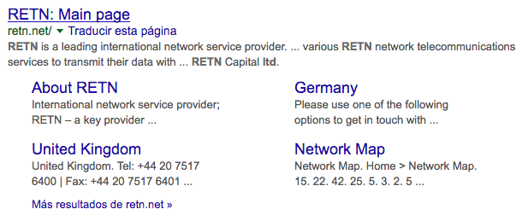

That’s an ISP. So in my case, the very first hop in my traceroute was from an ISP, which makes sense, because I was in a hotel with no internal network of its own).

1. Use the tools and methods shown above to determine the name or domain name of the ISP that shows up first in your traceroute on its journey to the destination. Do this for both traceroute cities/locations you tried to the university you chose.

_______________________ and _____________________

1. Estimate through how many different service providers your packet passes on its journey for each of the starting points. Not a router count, but a provider count. For example, in this traceroute to uh.edu, I count 4 providers: telmex, uninet.net.mx, telia.net, and tmc.edu.

KEVILONG-M-70EP:~ kevinlong$ traceroute uh.edu

traceroute to uh.edu (129.7.97.54), 64 hops max, 52 byte packets

1 telmex (192.168.1.254) 0.888 ms 0.574 ms 0.392 ms

2 dsl-servicio-l200.uninet.net.mx (200.38.193.226) 3.625 ms 3.063 ms 3.178 ms

3 bb-la-onewilshire-17-be4.uninet.net.mx (189.246.216.78) 34.910 ms 39.647 ms 31.969 ms

4 las-b24-link.telia.net (62.115.162.26) 42.678 ms 43.399 ms 57.788 ms

5 las-b21-link.telia.net (62.115.136.46) 34.196 ms 33.852 ms 34.073 ms

6 dls-b21-link.telia.net (62.115.123.136) 71.201 ms 65.057 ms

dls-b21-link.telia.net (62.115.137.106) 67.022 ms

7 dls-b23-link.telia.net (62.115.113.84) 63.254 ms 63.962 ms 66.134 ms

8 hou-b1-link.telia.net (62.115.114.252) 72.324 ms 72.563 ms 69.584 ms

9 baylor-ic-333516-hou-b1.c.telia.net (80.239.196.7) 73.149 ms 69.429 ms 70.600 ms

10 uh-2.chat.tmc.edu (192.31.88.231) 70.528 ms 69.996 ms 68.073 ms

11 * * *

12 * * *

13 * * *

14 www.superasmi.com (129.7.97.54) 69.665 ms 68.677 ms 69.980 ms

KEVILONG-M-70EP:~ kevinlong$

_______________________ and (if different) ________________________

1. (4 pts) Layers
   1. When you pass a packet through a router (letting it do its normal job), at which of the five TCP/IP layers is the software running that makes the routing/forwarding decisions? Give the number and name. Names are Physical, Data Link, Network, Transport and Application.

#: 3 Name: Network Layer

* 1. Suppose the device in row 5 had a small web server used to configure the router remotely, protected of course with a password. At what layer is the software running in that device that interacts with our browser? Remember, if you don’t know what layer it’s at, we discussed what answer you should assume is correct.

#: 5 Name: Application

Defend this answer: The this that is running that allows management is a doing so through a web application, its running a web server. Web servers run in the application layer.

1. (8 pts) Cookies

Choose your favorite browser. Pick a commercial site (a company that sells products that’s large enough to have a cool web site) that you don’t visit and don’t care if you have to log in again (we’re going to mess things up a little).

Find and open the cookie manager for your browser. You may have to search the help pages.

In google, here’s what I used: <https://support.google.com/chrome/answer/95647?hl=en-419>

In Firefox, I navigated to this site by entering it in the URL field:

about:preferences#privacy

1. So what’s the site you chose? www.rockabilia.com

Find and clear any cookies that have the name of the site (just for this site). Leave the cookie manager open so you can see immediately when cookies are added.

I chose [www.jcpenney.com](http://www.jcpenney.com/).

1. Go to the site’s home page. Consult the cookie manager again in your browser and search again for cookies for this site. Were cookies created by just opening their home page? xYes or ☐No. If yes, how many? 4

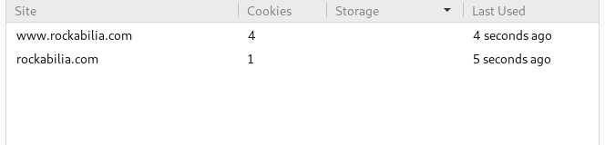

1. Click on a product on the web page. Observe the URL in your browser after you have clicked on the product. Paste it here.

Your URL: <https://www.rockabilia.com/browse/artists-groups/f/frank-zappa/frank-zappa-illustration-slim-fit-t-shirt-400373.html>

Do you see a pattern of variables and values encoded in the URL? For example, separated by ampersand symbols (&’s)? ☐Yes or xNo.

No variable, but I do see the directory structure of how they store products for a particular artist.

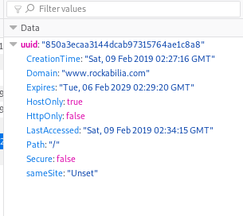

1. Add the product you were browsing above to your cart, and then clear the cache again for the domain while that web page is still displayed and the item is still in your cart. Now refresh the page. Is the item still in the cart? yes
2. Examine the cookies again. Look for the same cookie from (d). Was it replaced? Does it still have the same unique identifier as before?

That cookie in particular stayed the same, but more cookies appeared after I added it to my cart.

1. Wait a few minutes and go to a site with google ads, like nytimes.com. Did you see your cart item in one of the ads? I happened to need to go to aboutus.com/Gvt3.com (sort of random site) and look what ads I got! Lol. My browser might not remember what I put in my cart, but Google did!

I did not see any adds, I also turned off my add blocker and duck duck go tool. I tried multiple sites and none of them would display any adds. My add blocker must have screwed something up along the way.

1. Does the site you chose use custom URLs or cookies or both or neither to maintain state?

☐custom URLs and/or x cookies.